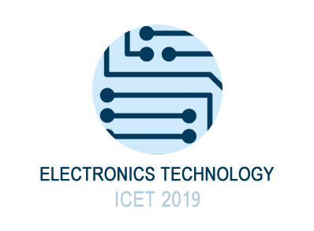

May 10-13, 2019 Chengdu, China

Presentation guidelines
Oral Presentation
Presentation type | Keynote | Invited | Oral standard | Oral Flash + Poster
Total duration (min) |  |  | 15 | 5
Talk (min) |  |  | 12 | 3
Questions (min) |  |  | 2 | during the poster sessions

Papers will be scheduled at 15-minute for “Oral standard” presentations, respectively. Plan to leave 2 minutes for transition to the next speaker, since participants should have the possibility to go between parallel sessions.
Preparation of Visuals
Each platform session room will be equipped with a Video projector, a computer and necessary peripherals to support PowerPoint and Acrobat Reader.

Poster Guidelines
The maximum poster size requested is ( 60 cm × 80 cm – W x H) in portrait format. The material required to display your posters will be provided onsite.

Preparation of Visuals

The poster must contain the following sections:
• Title of the contribution
• Author list and detailed contacts, corresponding author
• Context of the work
• Materials and Methods
• Results and Discussion
• Conclusions and Perspectives
• Selected literature references
• Acknowledgments (optional)

Poster Layout:
Top Left corner (8 cm)
Top Right corner and Center Your own logos
Please make sure the Logos banner has at least 8 cm height.

Center Title (Calibri, 80 pt)
Authors (Calibri, 54 pt)
Affiliations (Calibri, 24 pt)

Workspace
Whatever… Calibri, 18 pt (minimum)

Footer, centered
ICET2019 –The 2nd International Conference on Electronics Technology - May 10-13, 2019, Chengdu, China (Calibri, 36 pt, italics)

